Worthley, Manning

UNC Charlotte

Forecasting USD Euro Exchange Rate

1. **Introduction**

What could be better than a trip outside the United States to tour the Sagrada Familia, the most beautiful church in Spain, or enjoying a romantic dinner at a French café with the Eiffel tower gleaming in the glow of a sunset or visiting the roman Colosseums for an adventure to relive the past glories of the Roman Empire? Taking any of these vacations when the United States dollar surges relative to the euro! Foreign exchange rates inflections impact the avid traveler.

Beyond planning for the next vacation abroad, forecasting foreign exchange rates inherently affects international businesses and can result in margin variations brought on by not budgeting correctly for foreign exchange impacts. For example, an international manufacturing firm that buys inventory from vendors in Europe in United States dollars may budget to purchase inventories at today’s exchange rate but if the market exchange rate moves then the company will lose money. Thus, the profitability of this firm depends directly on its ability to accurately forecast the coming year’s exchange rate.

1. **Literature Review**

Forecasting foreign exchange rates is well published and researched topic. Research spans from papers that study the mean reversion of a foreign currency exchange rate to its purchasing power parity equilibrium to more recent studies on the adoption of applied artificial intelligence techniques like neural networks or machine learning. Both of these aforementioned topics have their merit and are briefly examined below.

*2.1 Machine Learning, Artificial Intelligence, Neural Networks*

Applying artificial intelligence methods to forecast the dollar to euro exchange rate, Tyree & Long (1995) explored the effectiveness of neural networks in comparison to conventional financial modeling techniques. Using daily data, they demonstrated that their neural network forecast underperformed in relation to the random walk generated forecast.

Beyond pure financial time series analysis, researchers have employed using machine learning to study the impact of social media on the foreign exchange market. In “Exchange Rate Prediction through Twitter”, Ozcan (2016) devises a machine learning algorithm to text mine millions of tweets to capture market sentiment and predict the foreign exchange rates in ten minute intervals. Ultimately, the author proves this model is better than AR (1).

*2.2 Conventional Econometric Modeling & Macroeconomic Insight*

In “*Modeling and Forecasting US Dollar / Euro Exchange Rate”*, Ghalayini (2014) analyzes if the exchange rate in the long term reaches its theoretical value. He attributes short term fluctuations to the business cycle. Further he notes that: “the PPP [purchasing power parity] theory explains the main part of the dollar euro exchange rate …” In the long term he found that the differential between the money supply of the United states and of European Union and PPP contribute the most statistically to his model but ultimately cannot forecast using his ARIMA model due to an autocorrelation problem.

In Bernd (2006), the author has a similar conclusion about the long term convergence of an exchange rate to its purchasing power parity equilibrium in the long run. He employs a non-linear smooth transition autoregressive (STAR) model to investigate the mean reversion of foreign exchange. Bernd found that the higher magnitude of deviation of the euro / dollar exchange rate from its implied PPP, the quicker the exchange rate reverts to its implied PPP.

1. **Data**

*3.1 Section Organization*

The variables that will be used to forecast the dollar/euro are explored in this section. After a short description of the variables and any possible transformations entailed, the stationarity of the variables will be assessed through the DF-GLS Test. The null hypothesis of this test assumes that the dataset is non-stationary while the alternative hypothesis of assumes stationarity.

*3.2 Dollar / Euro Exchange Rate*

The foreign exchange rate between the United States Dollar and the European Union Euro are taken from *FRED*. The data is measured in a monthly non-seasonally adjusted fashion from January 2000 to February 2017.

*3.2.1 Stationarity Exploration*

As the exchange rate can encompasses various impacts from macroeconomic exogenous variables, the exchange rate is likely to be non-stationary due to the structural breaks. For example, by simply analyzing a graph of FX during, the financial crisis of 2007/2009 seems to have shifted the exchange rate down as illustrated in Dollar / Euro Exchange Rate Chart outlined by the gray background.

Contrary to this notion, the DF-GLS test yields the below results. If the underlying process of the variable FX is a single mean and does not hold any long term trends, then we can reject non-stationarity at well below the 95% confidence level. The single mean estimate is shown in the above plot as the green line. For reference, an estimated trend line is also shown in red- its R squared is 0.1189.   
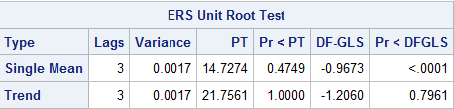

*3.3 Relative Purchasing Power Proxy*

As the theory of the Purchasing Power Parity goes, if a country routinely experiences increasing inflation then that country will realize weaker purchasing power relative to other countries. This purchasing power fluctuation ultimately influences the exchange rate negatively. To capture this process from inflation to an exchange rate impact, the United States consumer price index (CPI) and the European Union harmonized consumer price index (HCPI) were combined to create a differential inflation metric between the US and EU.

The US CPI, taken from *FRED,* is a metric of the monthly price level of all goods and is not seasonally adjusted. Published by the *EuroStat*, the European HCPI is a weighted average of price indices of 19 European countries who have accepted the use of Euros. The countries included are Belgium, Germany, Estonia, Ireland, Greece, Spain, France, Italy, Cyprus, Latvia, Lithuania, Luxembourg, Malta, the Netherlands, Austria, Portugal, Slovenia, Slovakia and Finland; essentially a fair representation of price levels in all of the EU. Also similar to the US CPI, the HCPI is monthly and not seasonally adjusted as well.

As CPIt represents United States consumer price index and HCPIt indicates the harmonized index, let the differential inflation index we will label as CPI_HCPIt equal the quotient $\frac{CPIt }{HCPIt}$.

*3.3.1 CPI_HCPI Stationarity Exploration*

Below in figure 1, CPI_HCPI is depicted over the time series from January 2011 to February 2017. A single mean is likely.

In figure 2, the DF-GLS test output from SAS indicates that the single mean is stationary because we can reject the null hypothesis of non-stationarity above a 99.99% confidence level as shown by the DF-GLS p-value <.0001. The estimated mean is plotted below in gray.

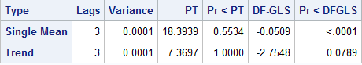

*3.4 Trade Balance & Current Account*

Including trade balances yields macroeconomic insight to a countries domestic demand for foreign currency which might prelude to the depreciation or appreciation of a currency. To capture this effect, the trade balance for the United States and a monthly proxy for a comparable monthly European series was collected. The United States trade balance was taken from *FRED.* The series is a seasonally adjusted monthly series measured millions of USDs. The proxy for the European trade balance is a current account dataset published from the European Central Bank. It is measured in millions of euros, is seasonally adjusted and represents the effect of the same 19 countries listed in the HCPI series.

*3.3.1 US Trade Balance Stationarity Exploration*

The US trade balance series seems to have a single mean as indicated by the chart and the DF-GLS test. We can reject the null hypothesis of non-stationarity with a high degree of statistical confidence. We will label this variable US_BAL.

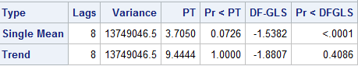

*3.3.2 EU Current Account Stationarity Exploration*

Using DF-GLS test on the level form of the EU current account yielded that the trend was causing non-stationarity. The test gave a p-value of 0.7045 which means that we would fail to reject that there is non-stationarity. To control for this non-stationarity, the difference of the variable is taken. The chart for the Differenced EU Current Account shows that the variable is stationary. The DF-GLS test also supports this assertion. With a p-value of less than 0.01 for the single mean source of non-stationarity, we can say that the series is now stationary. Results are below. This series will be referred to as d_EU_BAL.

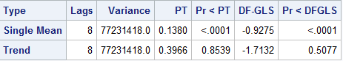

*3.2 Money Aggregates for US EU*

In macroeconomics, it is theorized that the money supply affects the exchange rate through inflationary pressure. An increased US money supply relative to the EU would decrease the foreign exchange rate due to an implied downward pressure on interest rates. With higher interest rates, foreign investors are incentivized to save in US dollars which drives the foreign exchange rate down To capture this implied effect, the US broadest money aggregate measure M3 and the similar EU M3 are combined to create a differential variable. This differential variable is calculated as the US M3 divided by the EU M3 and is defined as US_EU_M3.

The US money supply variable comes from *FRED* and the EU money supply comes from the European central bank. Both series are presented in a monthly seasonally adjusted fashion of millions of dollars / euros. The EU series accounts for the impact of the same 19 countries that are accounted in the HCPI series.

*3.3.2 Differential Money Aggregates Stationarity*

As the below chart and DF-GLS output allude to, the data appear to be stationary. The DF-GLS test also supports this notion as the p-value for the single mean is well below .05. This v

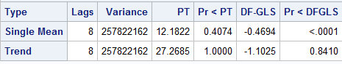

*3.2 Differential 10-Year Treasury Yields*

10-year treasuries are a proxy for the implied affect interest rates have on the demand for foreign currency. As the market interest rate decreases, the bond yield increases making the bond more attractive to domestic and foreign investors. Thus the demand for the domestic currency increases and impacts the foreign exchange rate.

The data for the United States 10-year treasury yields comes from *FRED.* It is a percent measured monthly and is not seasonally adjusted. Similarly, the European 10-year treasury yield is a percent annual yield and is not seasonally adjusted. The European treasury yield data is taken form the European Central Bank.

To analyze the relative effect of the two countries interest rate influences on the foreign exchange rate, a differential variable is created between the two countries’ yields on their treasuries. It is formulated as the US 10-year treasury yield divided by the European treasury yield.

*3.2 Stationarity of Differential 10-Year Treasury*

The DF-GLS test gives the p-value of less than 0.01 for the single mean source of non-stationarity. Meaning, that the null hypothesis that the differential series is non-stationary can be rejected. Thus the series is stationary.

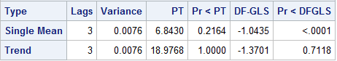

1. **Autoregressive Model Exploration**

As Ghalayini (2014) choose to use the differential effect from inflation, from money aggregates, and from interest rates to forecast the foreign exchange rate, we will include these variables a model to forecast as well. In addition to these variables and to control for more macroeconomic movements, the trade balances of both the United States and the European Union will be included. However for the European Union trade balance, the difference form will be used instead of the level form due to non-stationarity.

In this section, an autoregressive model is explored. Explicitly, the model is: $$FX = FX_{t-1}+CPI_HCPI_{t} + US_EU_M3_{t} +US_EU_BND_{t}+ US_BAL_{t} +d_EU_BAL_{t} +U_{t}$$

$$U_{t} is normally distributed$$

First we test for the relevance of the variables for forecasting purposes with the Granger Causality Test. Second, the lag order is determined for the autoregressive model. Finally, tests are employed for autocorrelation and the model is evaluated.

*4.1 Granger Causality*

The Granger Causality test examines if a data series is useful for forecasting another time series. The null hypothesis is that a series does not Granger cause another with the alternative being that the series does indeed Granger cause another data set.

Employing the Granger test, the following conclusions can be made with above 95% confidence. The foreign exchange rate does not Granger cause the model. The inflation rate differential variable CPI_HCPI Granger causes a relationship with the foreign exchange rate and the remainder of the model. The differential money aggregates, US_EU_M3, Granger causes a relationship between the foreign exchange rate and the remaining model. The US trade balance, labeled as US_Bal in the SAS output, Granger causes the foreign exchange rate and the rest of the model. The output from SAS is included below.

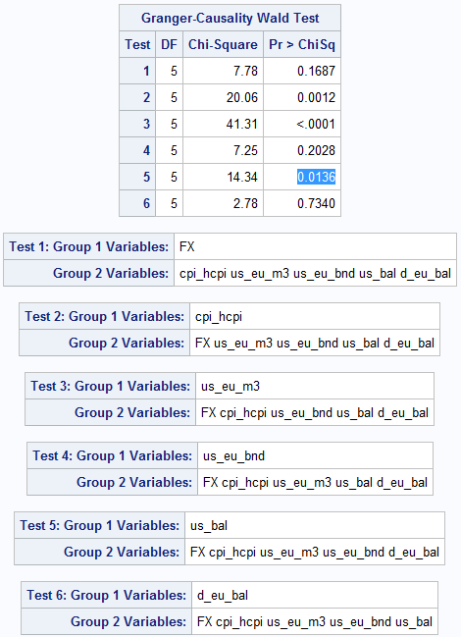

As a majority of the individual variables Granger causes a relationship between FX and the model, the model has some predictive power and can be used to forecast the foreign exchange rate.

*4.3 Determining Lag Order for Autoregressive Econometric Model*

The selection criteria to determine the appropriate lag order is to choose a model with the lowest Schwartz Bayesian Criteria (SBC) statistic. This statistic assists the econometrical specifying a model by penalizing the addition of any variable that is not statistically significant. With this in mind, the regression model is ran with multiple lag orders. Estimates of SBC are determined by running a regression with the Yule-Walker method- a method that controls for the negative side effects of autocorrelation. Including one lag variable gives the SBC of -698.13682. Running the regression again for a second lag, the SBC estimate is -690.79127. As increasing the number of lags increases the SBC statistic, the determined lag order is 1.

*4.3 Autoregressive Regression Results*

With the lag order specified, the regression model gives the below SAS output. The model with only statistically significant variables is estimated to have the relationship:

$$FX = -0.82276*FX_{t-1}+0.9411*CPI_HCPI_{t} -0.0000006357*US_EU_M3_{t} -0.0676*US_EU_BND_{t}$$

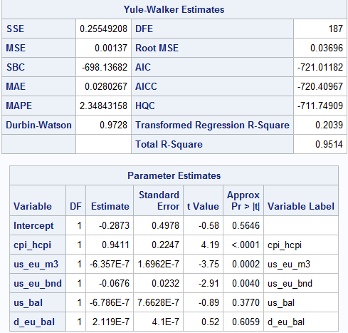

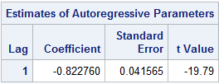

*4.4 Interpretation of Results*

The most notable attribute of the regression output is that the statistical significance of the variables estimated by the Yule-Walker method are far less than the conventional OLS estimates. This alludes to a sizeable autocorrelation problem. Further, the transformed R squared value is incredibly low compared to the total R square value which again suggests that there is a large impact from autocorrelation.

*4.4.1 Variable Interpretations*

The series CPI_HCPI has a positive coefficient and has a quite low p-value of less than 0.0001 which is strange. The differential inflation rate was expected to have a negative impact on the foreign exchange rate. As inflation of one country increases to a high degree relative to another the foreign exchange rate should decrease between the two countries. This points to a spurious estimated relationship.

US_EU_M3 has a negative coefficient and is statistically significant which was expected. As the Federal Reserve Bank increases their money supply while European Central holds a constant money supply, the influx of new dollars causes depreciation to the domestic currency relative to the Euro.

Another statistically significant variable is US_EU_BND which is the variable measuring the relative bond yields on 10-year treasuries between the US and the EU. As the market interest rate decreases, the bond yield increases making the bond more attractive to domestic and foreign investors. Thus the demand for the domestic currency increases and impacts the foreign exchange rate.

*4.5 Autocorrelation*

Noting the possible autocorrelation problem, the model is evaluation for it. Autocorrelation can cause issues with the estimates of the standard deviation which directly impacts the statistical significance of a variable. To test for this, we will use the estimates of the Pearson correlation coefficients for the interactions between the variables and the Breusch–Godfrey serial correlation test. *4.5.1 Pearson Correlation Coefficients*

The associated SAS output is depicted below. Interpreting the below results; the highest correlation coefficient is between the differential money supply variable US_EU_M3 and the differential 10-year treasury yield. This may lead to an autocorrelation problem.

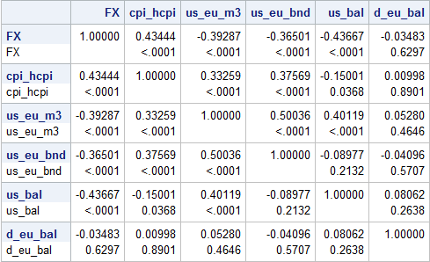

*4.5.2 Breusch–Godfrey Test*

A more formal test of autocorrelation is the Breusch-Godfrey test. This test has the null hypothesis that there is no serial correlation in a series.

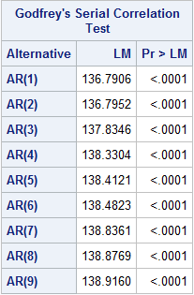 After performing this test, it is apparent there is an autocorrelation problem. Up to nine lags were considered in the test. All of these nine lags were statistically autocorrelation or have a p-value below 5% indicated the rejection of the null hypothesis of no autocorrelation. Below is the output from SAS.

1. **VAR Model Exploration**

Given strong evidence that there is an autocorrelation problem, the simple Autoregressive model has major flaws. While theory suggests a structural relationship between the model’s variables. The autoregressive model with only one lag on the dependent variable could yield spurious relationships. To address this problem, A VAR model will be explored. It will allow for more than one variable to evolve over time and allow for more than one lag across all variables which will address the statistical significant lagged variables.

First the model needs to be re-evaluated for the right specification under the VAR model. Then the lag order will be assessed. Finally, the new model will be interpreted.

*5.5.1 VAR Model Specification*

Running a VAR regression on six different combinations of the previous model’s variables with only one lag, the below table is generated. In this table the model and SBC statistic is listed.

|  |  |
| --- | --- |
| Model | SBC |
| FX= cpi_hcpi | -2679.93 |
| FX= cpi_hcpi + us_eu_m3 | 842.2268 |
| FX= cpi_hcpi + us_eu_bnd | -3320.9 |
| FX= cpi_hcpi + us_eu_m3 + us_eu_bnd | 184.9072 |
| FX= us_eu_m3 + us_eu_bnd + us_bal + d_eu_bal | 8518.778 |
| FX= cpi_hcpi + us_eu_m3 + us_eu_bnd + us_bal + d_eu_bal | 7023.187 |

Analyzing the above table, the model that we will use to forecast is FX= CPI_HCPI + US_EU_BND given it has the lowest SBC score. Interestingly enough, these variables are said to be macroeconomic forces that shape the exchange rate - the inflation differential and the interest rate differential between the US and EU.

*5.5.1 VAR Lag Order Selection*

Similar to the model selection criteria that has been followed thus far, the lag order is determined by the model with the lowest SBC. The estimates for this statistic are displayed below. The model that will be used for the regression and forecasting is the VAR (1) version of the model.

|  |  |  |  |
| --- | --- | --- | --- |
| Model | VAR (1) | VAR(2) | VAR(3) |
| FX= cpi_hcpi + us_eu_bnd | -3320.9 | -3279.67 | -3242.17 |

*5.5.2 VAR Regression Results*

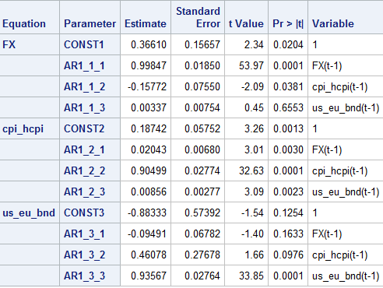  
 As indicated above in the FX model, the lagged dependent variable is highly statistically significant. Also, most notably, the coefficient on the inflation differential is statistically significant and is negative as expected – signifying that this model might be more accurate than the previous model.

1. **Forecasting**

In this section, a VAR (1) model is further scrutinized for forecast accuracy. To accomplish this, an in-sample forecast is created and then compared with other simple conventional model such as the AR (1) and the ARIMA model. Once this is verified, a two year forecast is generated with the best model.

*6.1 Choosing ARIMA*

To choose the best ARIMA model parameters, q and p+d, the SCAN functionality was used in SAS. This output suggested the models ARIMA (1, 1) or ARIMA(2,0). By analyzing the effectiveness of the models by selecting the ARIMA model with the lowest SBC, ARIMA (2,0) is the most effective model.

*6.2 Forecast Error Comparison*

Below displays the in-sample forecasts of the US dollar / Euro exchange rate.



It appears that the VAR (1) model does not have a lesser forecast error than the ARIMA model or AR (1) model. This indicates it’s ineffectiveness to forecast accurately or reliably. Therefore the best forecastable model would be an ARIMA model.

1. *An ARIMA(2,0) Forecast*

Given the preceding analysis, the ARIMA model was found to have the best forecast accuracy. This model yields the below results from SAS.



1. **Conclusion**

Given the trials and tribulations of exploring the various models and datasets in this research, a forecast cannot reasonably be generated that outperforms an AR (1) or an ARIMA model. Even after all of the macroeconomic insight, the models derived in this paper do not seem to bear accurate forecasts with the tools used. With this said, the inherent relationship in the model may very well be non-linear.

1. **References**

Board of Governors of the Federal Reserve System (US), U.S. / Euro Foreign Exchange Rate [DEXUSEU],

retrieved from FRED, Federal Reserve Bank of St. Louis;

https://fred.stlouisfed.org/series/DEXUSEU, April 27, 2017.

Brent, S. (2006). Is reversion to PPP in Euro exchange rate non-Linear? European

Central Bank, working paper series no 682/ October.

Ghalayini, L. (2014). Modeling and Forecasting the US Dollar / Euro Exchange Rate.

International Journal of Economics and Finance, 6(1), 194-207.

Ozcan, F. (2016). Exchange Rate Prediction from Twitter’s Trending Topics.

Retrieved from <http://sites.uci.edu/fulya/files/2016/03/Exchange-Rate-Prediction-from-Twitters-Trending-Topics-1.pdf>

Tyree, E. W., & Long, J. A. (1995). Forecasting currency exchange rates: Neural

networks and the random walk model. City University Working Paper, Proceedings of the Third International Conference on Artificial Intelligence Applications, New York. Retrieved from <http://citeseer.nj.nec.com/131893.html>

Silvia, John E., Azhar Iqbal, Sam Bullard, Sarah Watt and Kaylyn Swankoski,2014, Economic and

Business Forecasting: Analyzing and Interpreting Econometric Results. Hoboken, NJ: Wiley.

Statistical Office of the European Communities. (1990). EUROSTAT: Regional statistics: Reference

guide. Luxembourg: Eurostat.

Stock, James H., and Mark W. Watson, 2007, Introduction to Econometrics 2nd Edition. Boston, MA:

Pearson/Addison Wesley.